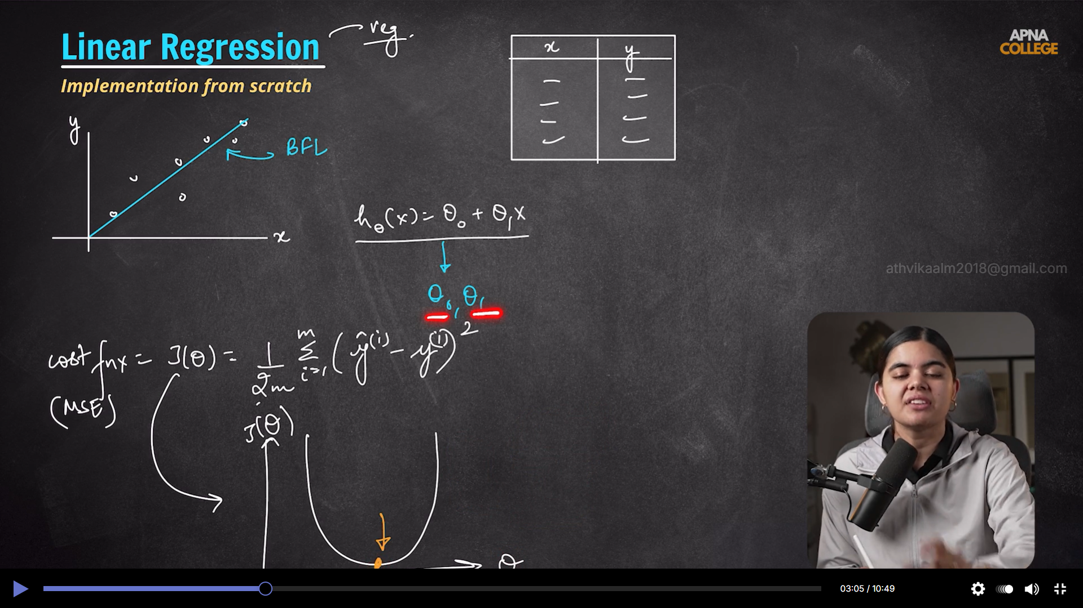

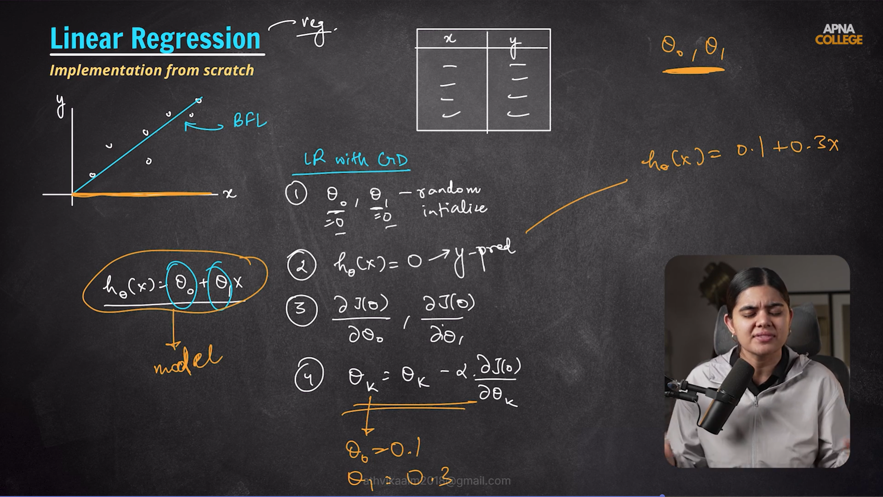

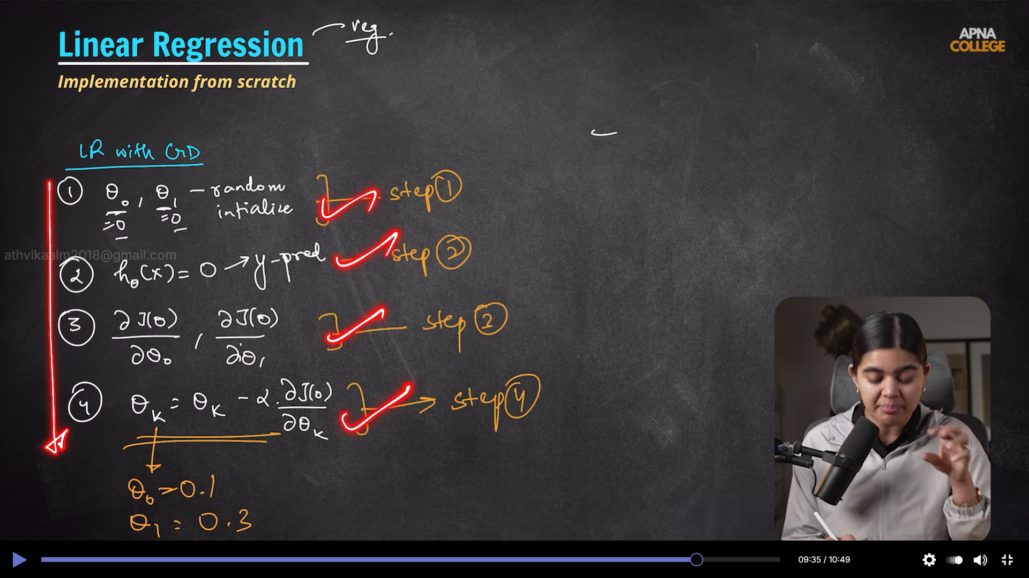

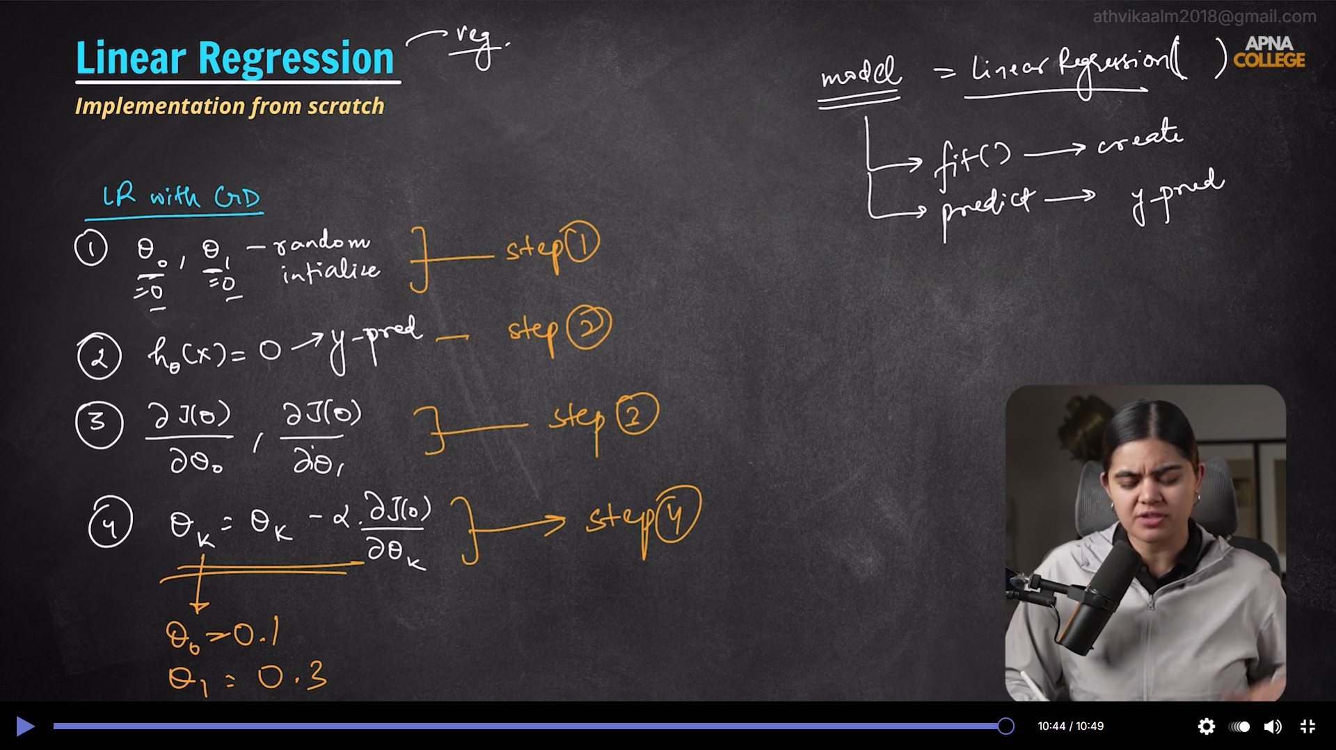

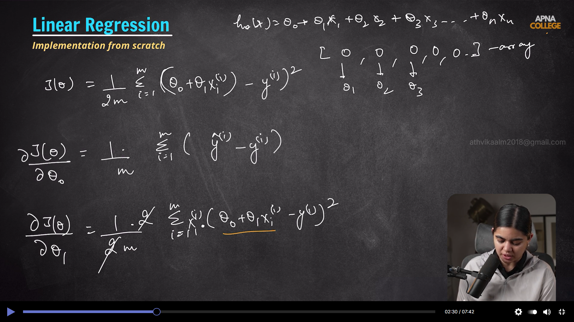

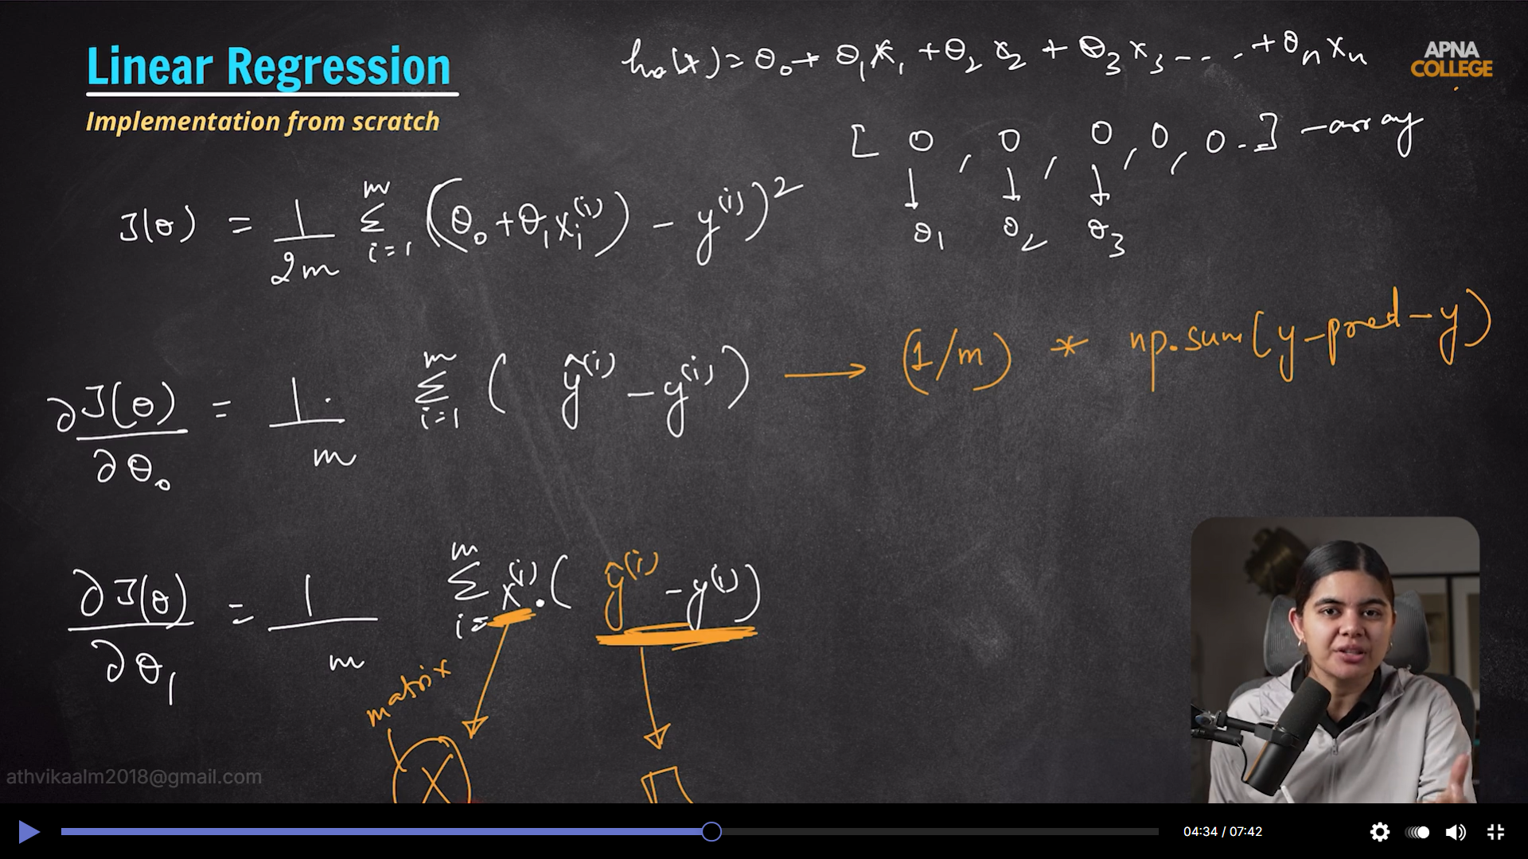
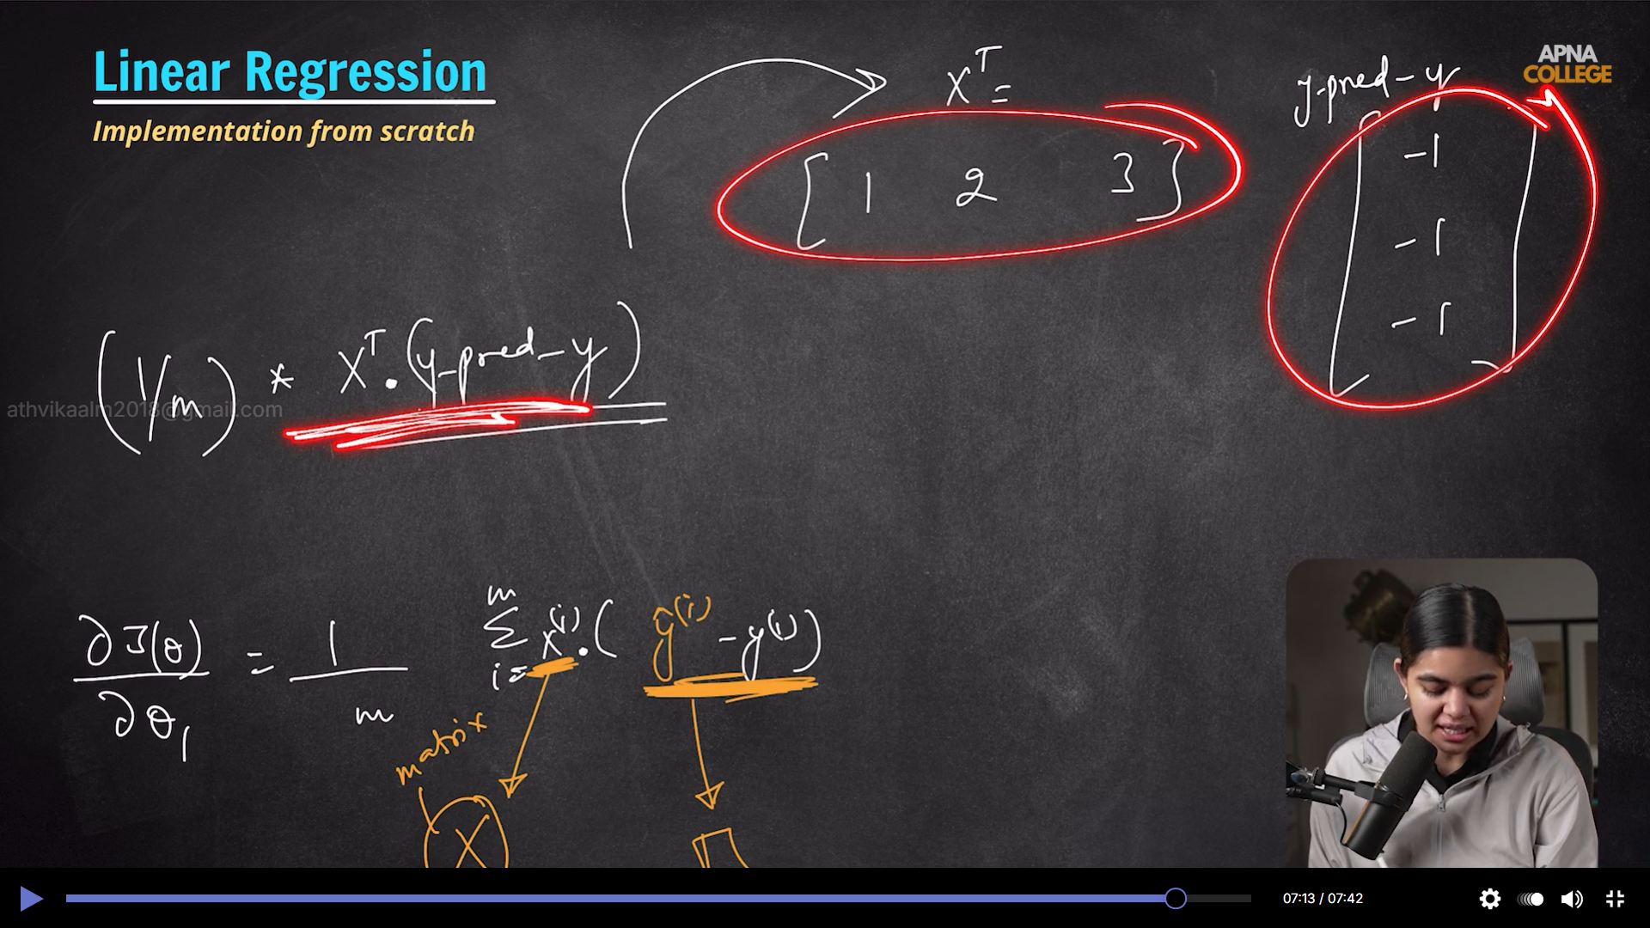

Small data – OLS
Large data with practical dataset real time – GD
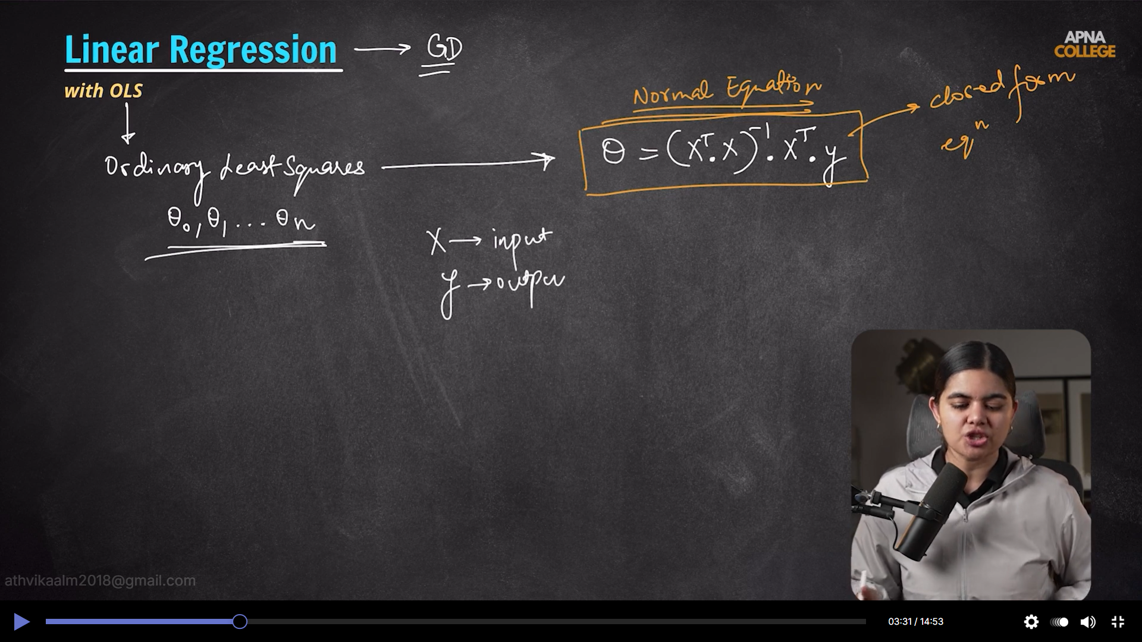
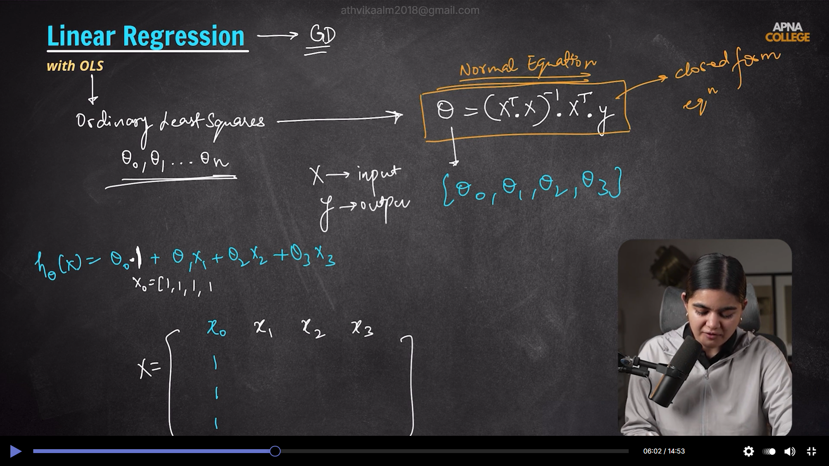

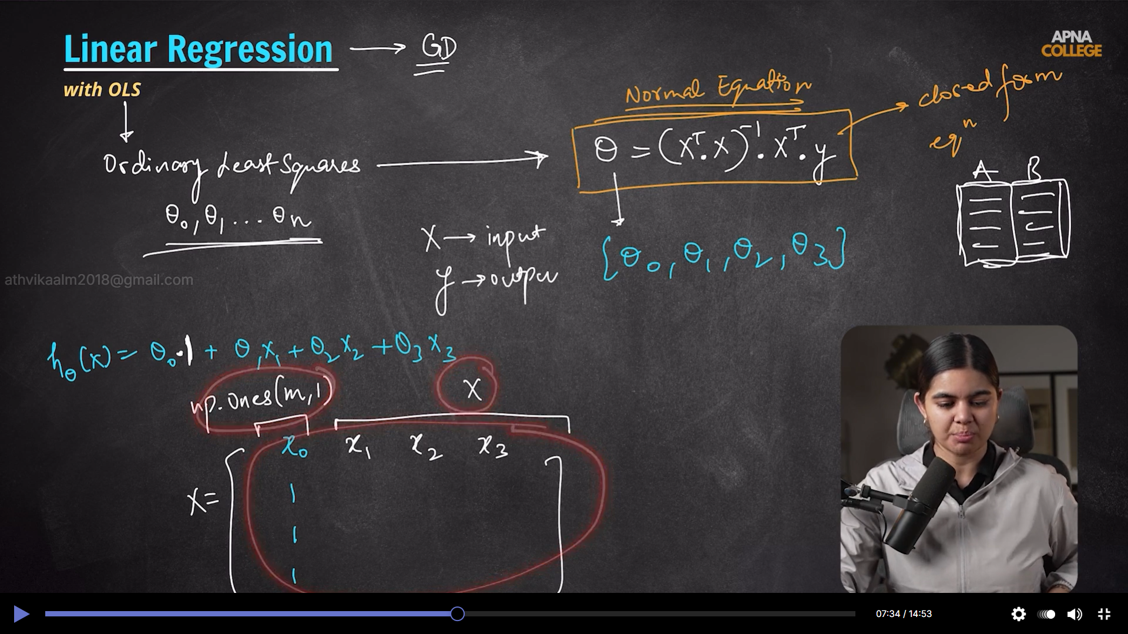

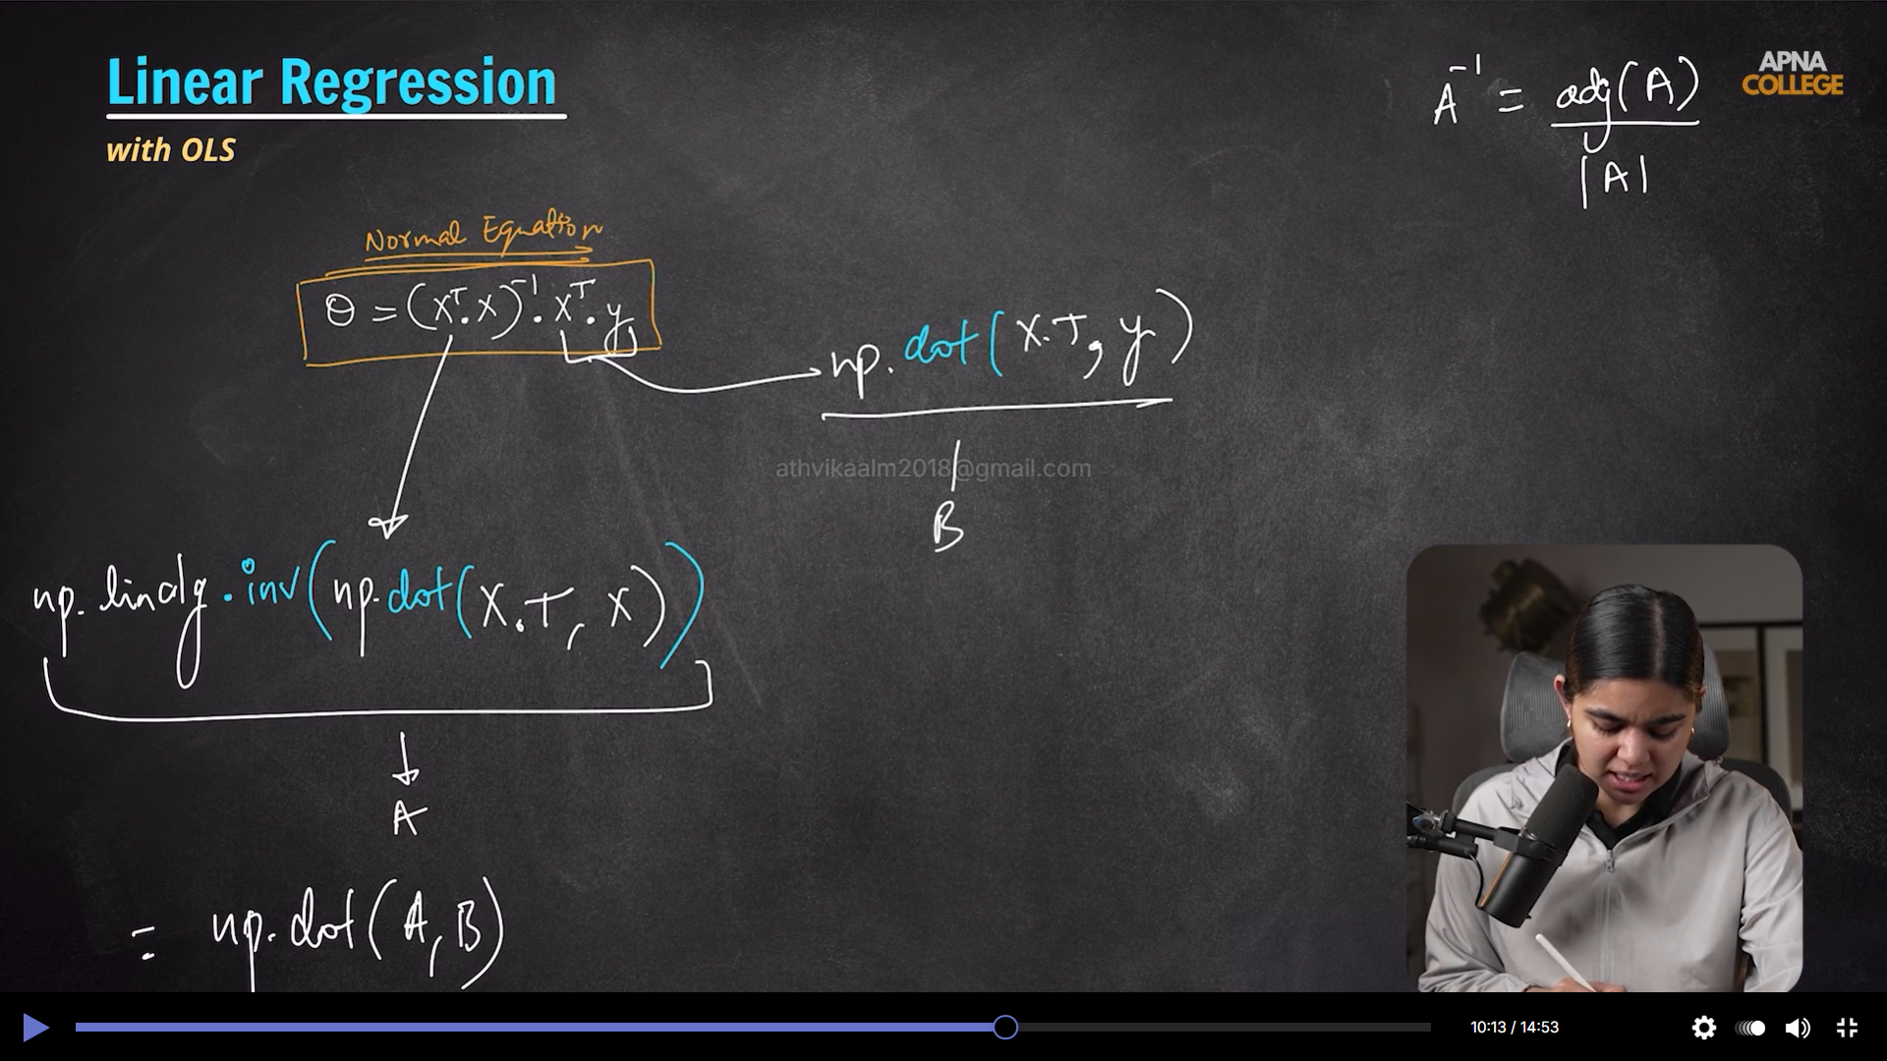


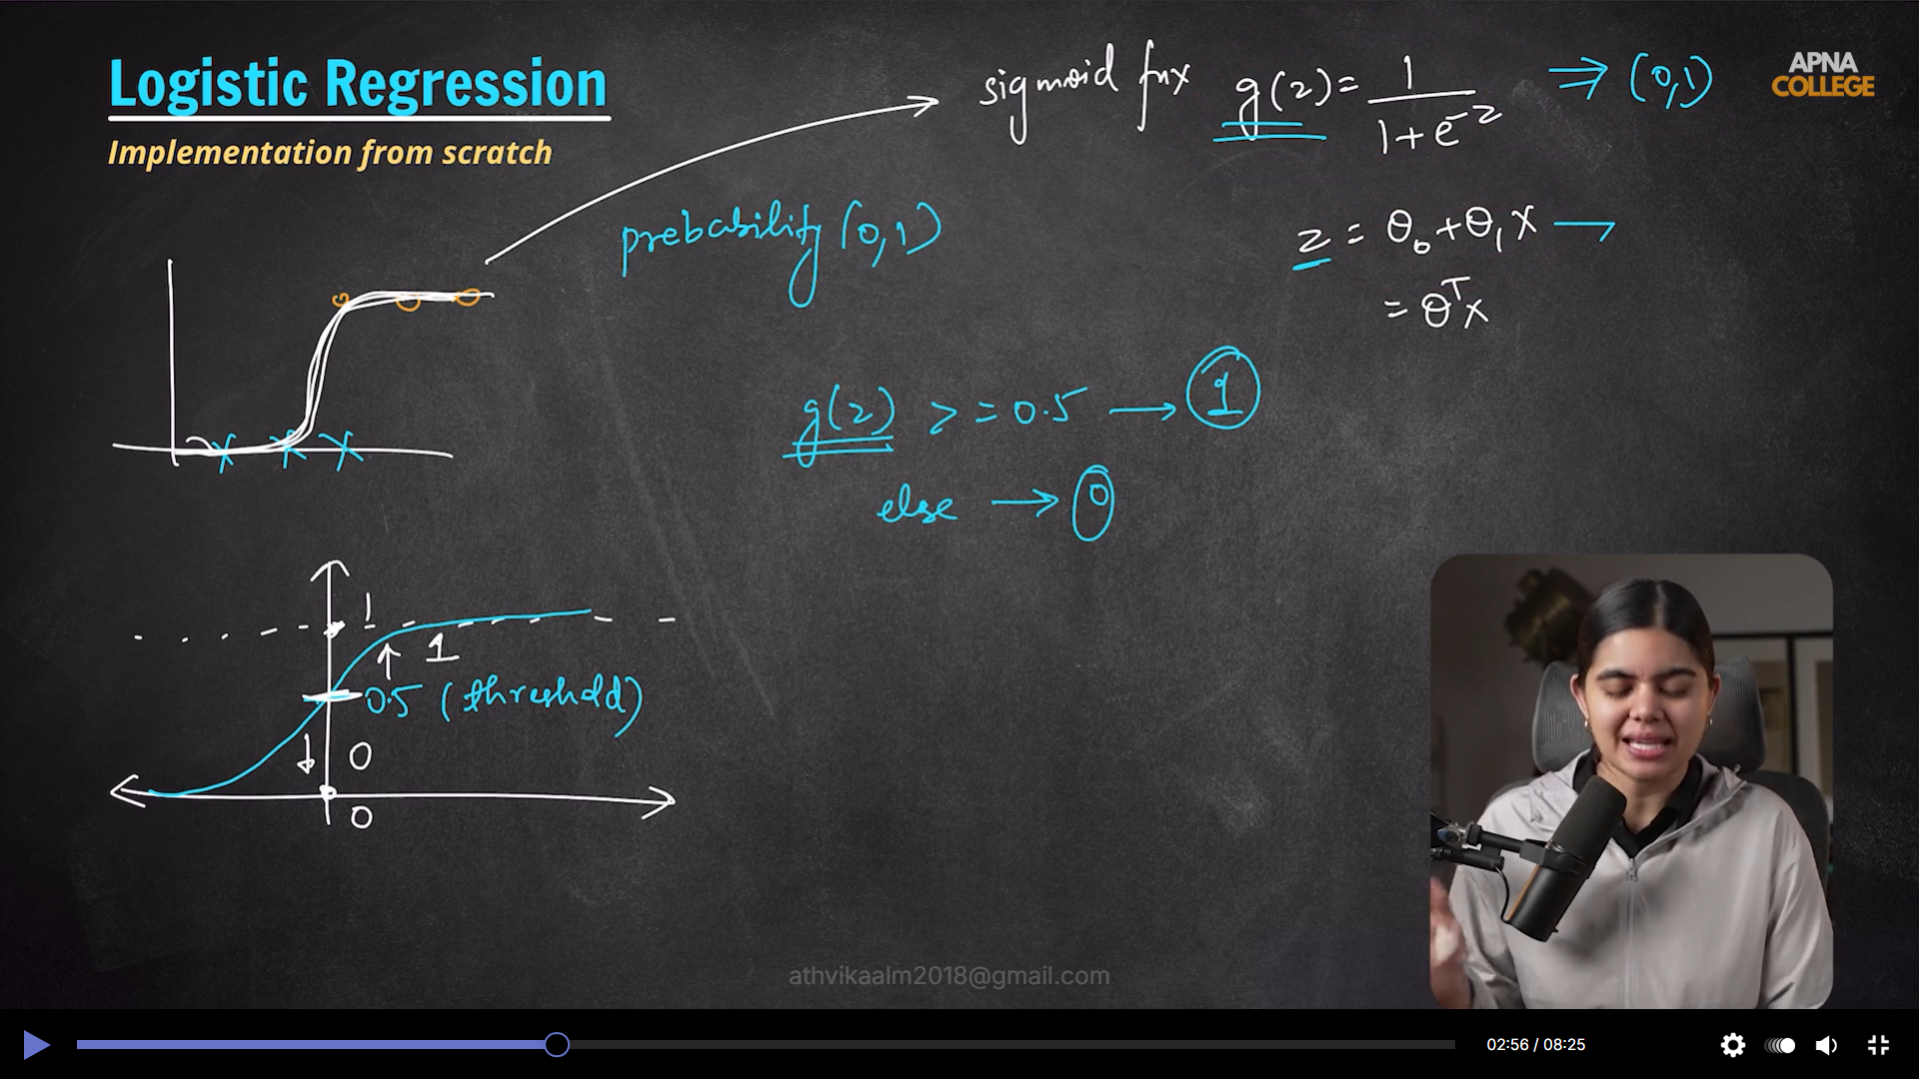

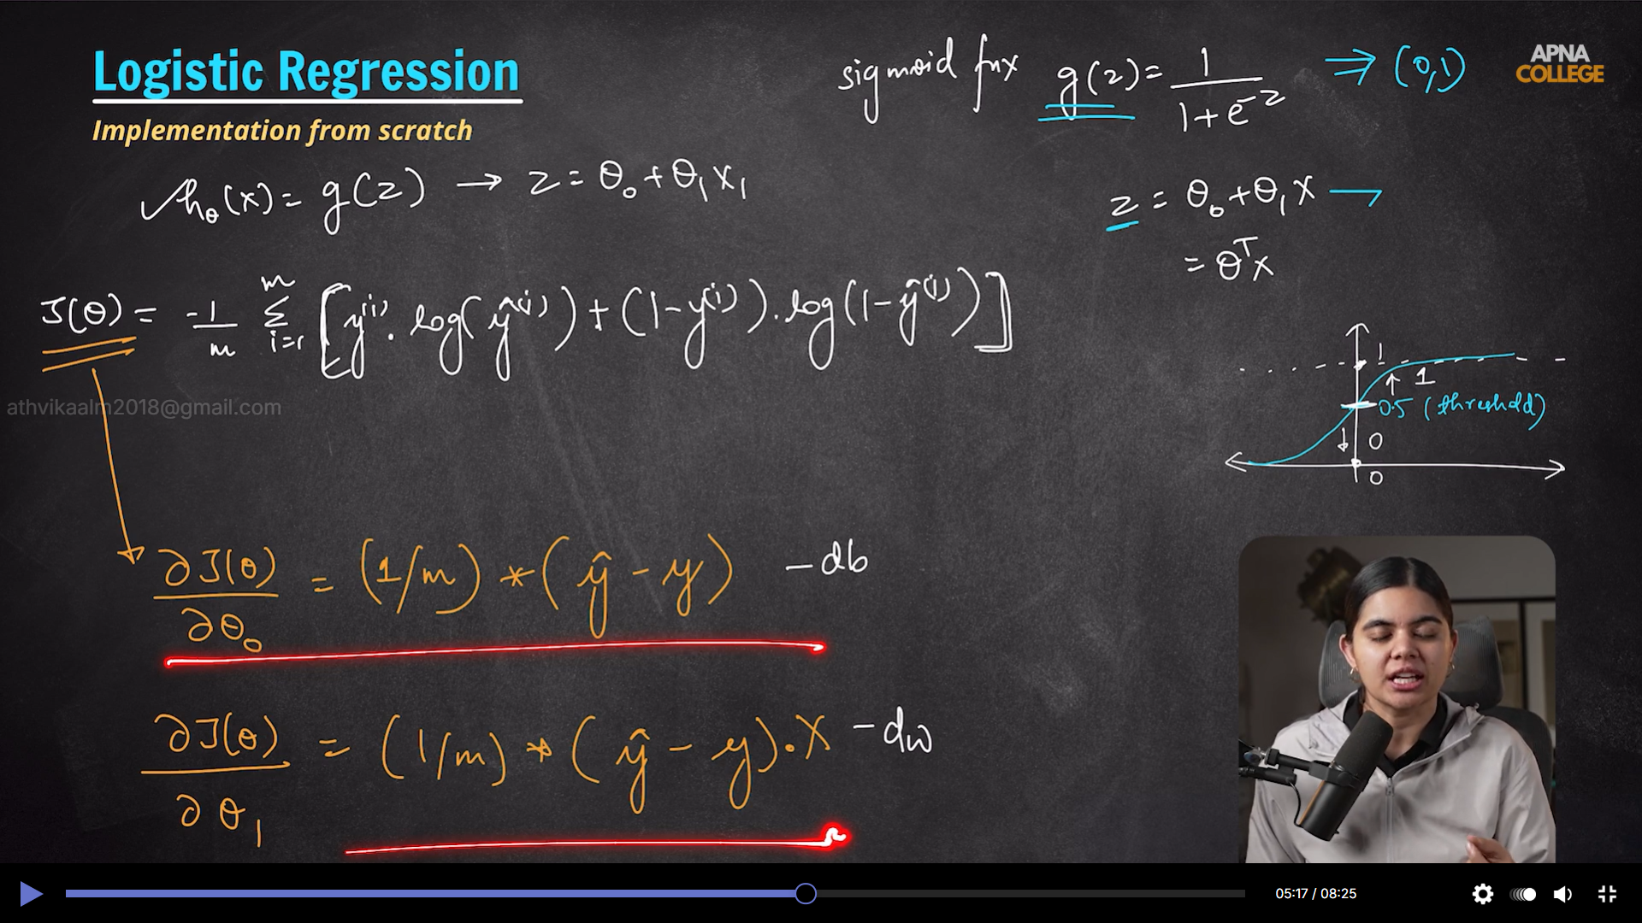

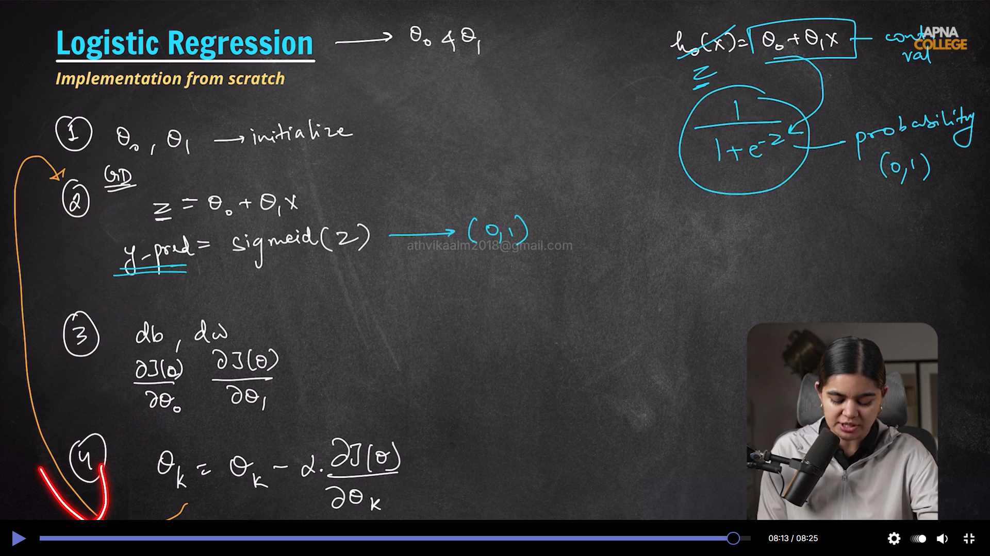

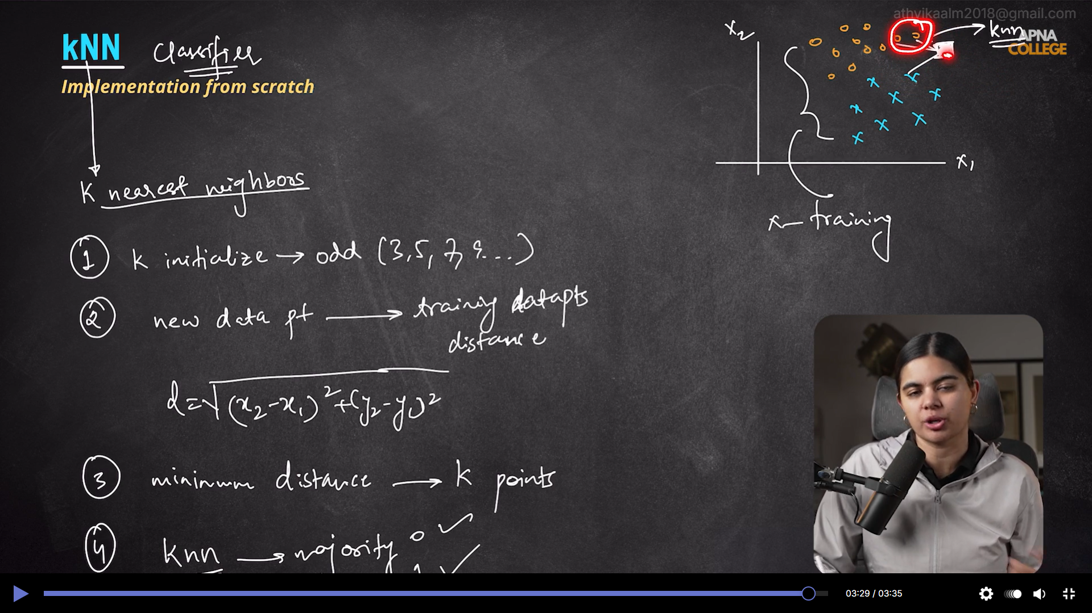

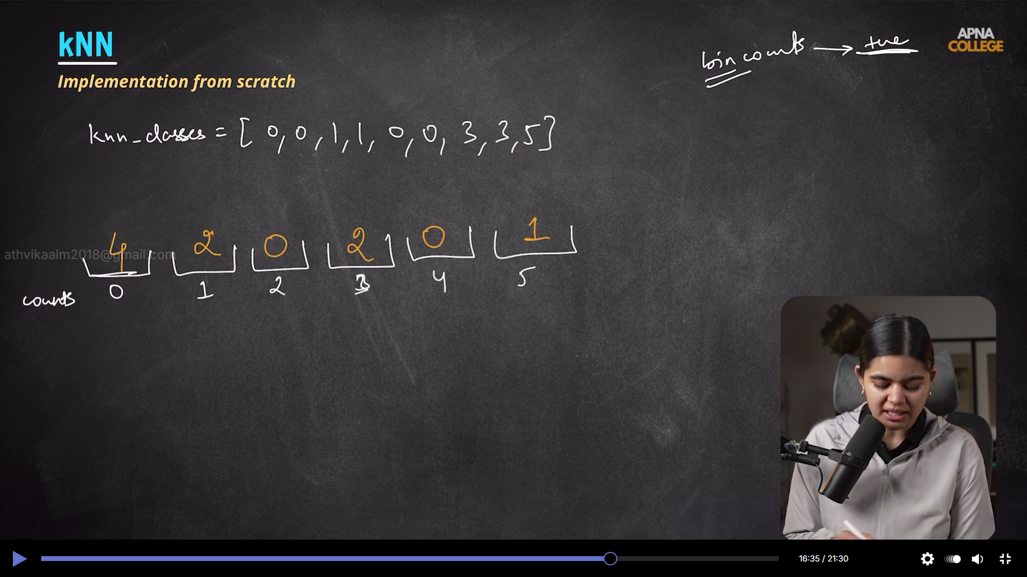

I’ll clarify this directly: in KNN voting, `mode` is valid, but `np.bincount` is usually preferred for numeric class labels because it is simpler and faster for this exact task.You can use mode. It is not wrong.

`np.bincount` is preferred in many KNN implementations because:

1. It is very fast for non-negative integer labels.
2. It gives class frequencies directly, so `argmax` picks the winner easily.
3. It works nicely even when labels skip values (like your `0,1,3,5`; missing classes just get count `0`).

For your example, counts are:
- class 0 -> 4
- class 1 -> 2
- class 3 -> 2
- class 5 -> 2

So predicted class is `0`.

You can do the same with mode, but it is generally less efficient and tie behavior can differ by library/version. For KNN, `bincount + argmax` is the common pattern when labels are integer-encoded.

No problem at all! Let’s break it down with an example. 🧭
In regression, because we use the mean (average), every single neighbor's value is factored in. If you have neighbors with values $[10, 11, 12, 100]$, that "100" is an outlier 🚀. It will pull the average way up to $33.25$, even though most neighbors are around $11$.
In classification, we use the majority vote. If your neighbors' labels are $[0, 0, 0, 1]$, the majority is clearly $0$. The outlier (the $1$) gets completely ignored. This makes classification more "robust" to outliers, while regression is much more sensitive to them. 📊
Now that your logic is set in knn_reg_mine.ipynb , let's try it out with the data from your assignment:
- Training Features ($X$): [[1], [2], [3], [4], [5]]
- Training Targets ($y$): [2, 4, 6, 8, 10]
If we want to predict the value for a test point $X = [6]$ using $k=3$, which three points from our training set are the closest neighbors? 🏘️

